The Three Rs of Anxiety Management
Recognize, Relax, Redirect
- Recognize that there is a physiological reason for anxiety.

How anxiety works in the brain.
Departments of the brain Main function of that part of the brain
Prefrontal Cortex = Manager
Hippocampus = Librarian (Memories)
Insula = Kindness Department
Amygdala = Security guard/protector

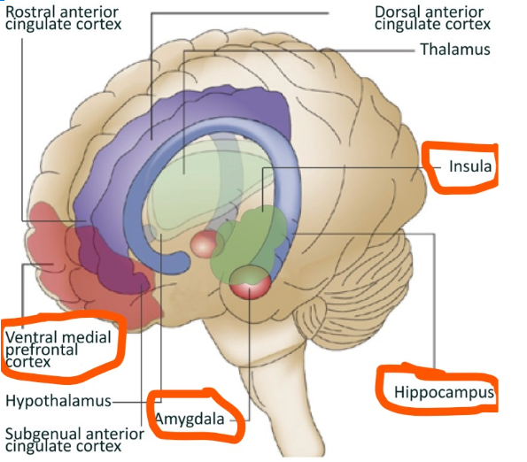

The Amygdala has not changed for thousands of years. Primitive man had to be extremely alert to survive. The Amygdala does not know this is no longer true. Your brain is telling you there might be danger. That results in anxiety. The Amygdala needs to be calmed so the other departments of the brain can work to determine if there really is a danger.

2) Relax to reduce the intensity.
Mindfulness = closely noticing our direct experience in the present moment without judgement and with kindness
Mindfulness increases: Mindfulness decreases:
Focus and memory Worry/obsessive thinking
Cognitive flexibility Stress and threat perception
Stress Resilience Emotional reactivity
Kindness/compassion Interpersonal conflict
Examples of ways to practice mindfulness
- Pay attention. It's hard to slow down and notice things in a busy world. Try to take the time to experience your environment with all of your senses — touch, sound, sight, smell and taste. For example, when you eat a favorite food, take the time to smell, taste and truly enjoy it.
- Live in the moment. Try to intentionally bring an open, accepting and discerning attention to everything you do. Find joy in simple pleasures.
- Accept yourself. Treat yourself the way you would treat a good friend.
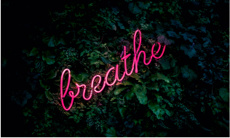
- Focus on your breathing. When you have negative thoughts, try to sit down, take a deep breath and close your eyes. Breath in through your nose to a count of 4. Hold it in for a count of 4, then blow your breath out through your mouth to a count of 4. Think about the temperature of your breath. As you calm, your breath becomes cooler. Sitting and breathing for even just a minute can help.
You can also try more structured mindfulness exercises, such as:
- Body scan. Lie on your back with your legs extended and arms at your sides, palms facing up. Focus your attention slowly and deliberately on each part of your body, in order, from toe to head or head to toe. Be aware of any sensations, emotions or thoughts associated with each part of your body.
- Sitting meditation. Sit comfortably with your back straight, feet flat on the floor and hands in your lap. Breathing through your nose, focus on your breath moving in and out of your body. If physical sensations or thoughts interrupt your meditation, note the experience and then return your focus to your breath.
- Sensory walk. Find a quiet place 10 to 20 feet in length, and begin to walk slowly. Focus on the experience of walking, being aware of the sensations of standing and the subtle movements that keep your balance. Focus on each of your 5 senses as you walk: what do you….see, feel, smell, taste, hear? When you reach the end of your path, turn and continue walking, maintaining awareness of your sensations
3) Redirect the anxiety energy

- Try to see your anxious thoughts as guesses, not as facts. Your mind is trying to protect you by predicting what could happen-but just because something could happen doesn’t mean it will. Don’t give power to a thought that is hurtful.
- Practice mindfulness of observing your thoughts, rather than reacting to them. Think of your thoughts as clouds floating by.
- Focus on direct experience. Your mind makes up stories about who you are and about your safety and lovability. Not all of these stories are accurate. What is your experience in the present moment?
- Label the type of thought you are having, rather than paying attention to its content. Watch your thoughts and when you notice a judgment (e.g., how good or bad the situation is), go ahead and label it as Judging. If you notice a worry (e.g., that you are going to fail or experience a loss) label it as Worrying. If you are criticizing yourself, label it as Criticizing. This gets you away from the literal content of your thoughts and gives you more awareness of your mental processes. Do you want to be spending your time judging and worrying? Are there less judgmental or worried ways to see the situation?
- Stay in the present. Is your mind regurgitating the past? Just because something negative happened in the past doesn’t mean it has to happen today.
- Broaden your view. Are you focusing too narrowly on the threatening aspects of a situation, rather than seeing the whole picture? Anxiety makes our minds contract and focus on the immediate threat without considering the broader context. Is this situation really as important as your anxiety says it is?
- Decide whether a thought is helpful. Just because a thought is true doesn't mean that it is helpful to focus on—at least not all the time. Focus your attention on what is helpful and let the rest go! Don’t give power to a hurtful thought.
- Get up and get going. Worrying over an issue without creating a solution will not help you solve the problem. It may, in fact, make you less likely to act by feeding your anxiety. When your mind is stuck in a loop, you can interrupt it by getting up and moving around or doing a different task or activity. When you sit back down, you should have a different perspective.

Information taken from:
“Anxiety in Children During the Covid-19 Crisis” webinar by Steven O’Brien, PSY.D.
“Example of Ways to Practice Mindfulness” Mayo Clinic website
“9 Ways to Calm Your Anxious Mind” Psychology Today article by Melanie Greenberg Ph.D

